Kantar Executive Committee

James Brooks, Chief Operations Officer, Kantar

James Brooks joined Kantar in 2004 as Global Operations Director with Kantar Worldpanel. During his career with Kantar he has also held the positions of Operations Director with Kantar TNS and Chief Operations Officer of Kantar’s Insights Division.

Before joining Kantar, James spent 10 years at IRI in a combination of commercial and operational roles. In these roles James has always brought a client focused approach ensuing that are operational capabilities are aligned to the needs of our clients.

Nathalie Burdet, Chief Marketing Officer
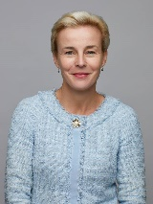

Nathalie Burdet joined Kantar as Global Marketing Leader of the Insights Division in 2018. She was appointed Kantar’s Chief Marketing Officer in June 2019.

Prior to this Nathalie held progressively senior marketing leadership roles across the FinTech industry, including at NEX Group (Formerly ICAP) where, as Head of Marketing and Brand Strategy, she developed, launched and built the NEX brand globally, and Thomson Reuters where she led the internal marketing for the flagship Eikon product.

Nathalie holds a LLM in European and international business law and a Postgraduate Diploma in Marketing from the Chartered Institute of Marketing in London.

Scott Carter, Chief Human Resources Officer

Scott Carter joined Kantar in 2010 as global head of recruiting, followed by appointments as group HR director for a portfolio of global Kantar subsidiaries in 2013 and promotion to the role of chief HR officer for Kantar Media in 2015. Prior to joining Kantar Scott held leadership roles at Price Waterhouse and a number of technology companies.

Lynnette Cooke, CEO, Health division, Kantar
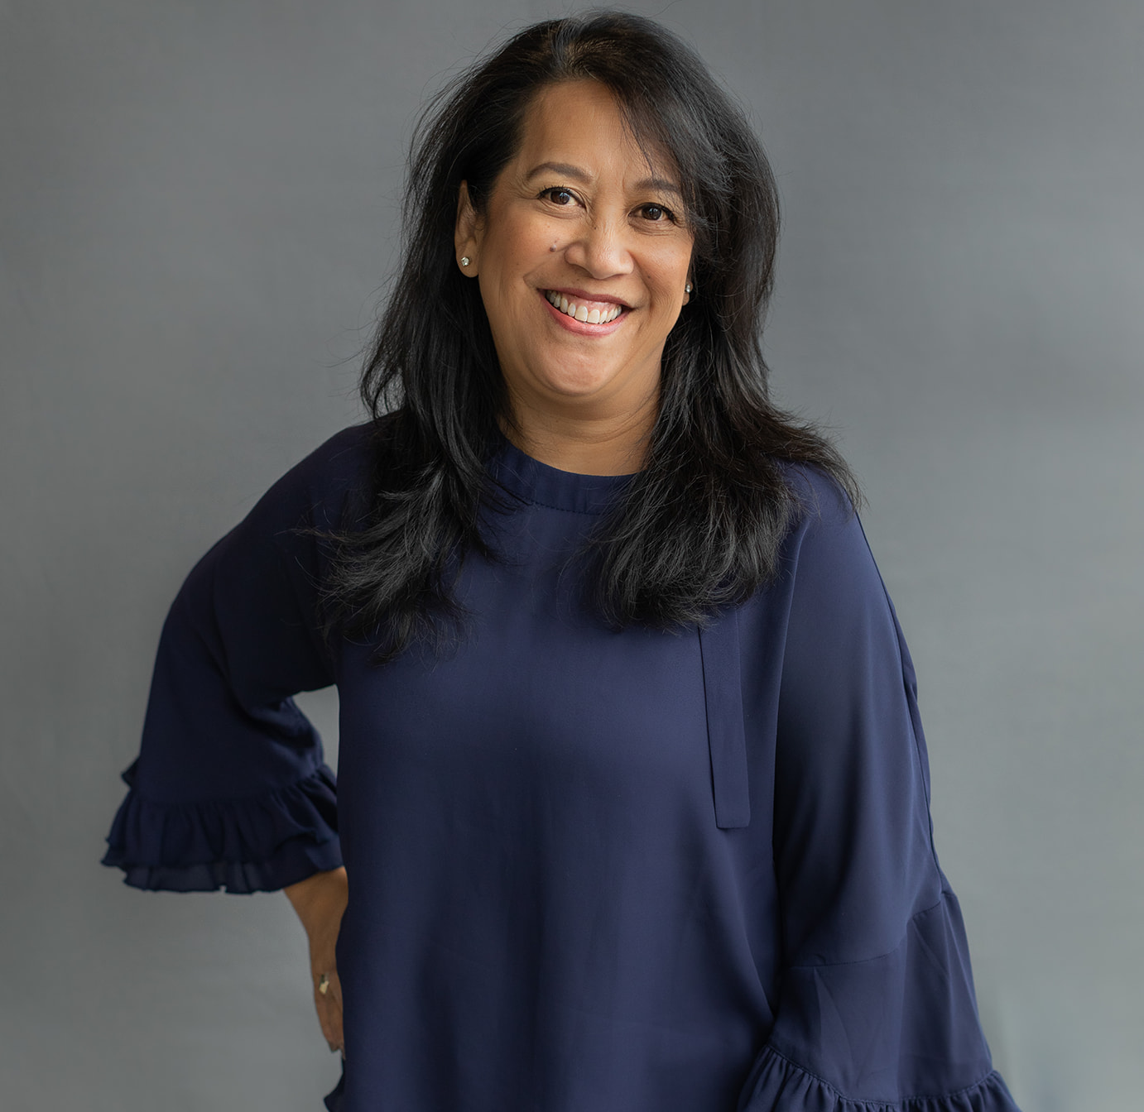

Lynnette Cooke leads the global Health division for Kantar, guiding the organisation through organic and acquisition-related growth. Known as a great connector of people, she creates diverse teams to challenge each other and generate the best ideas for serving clients.

Drawing on her consumer background and product management experience at Newell Rubbermaid, Lynnette brings fresh and innovative perspectives to the development of health specific offers and services with a distinct focus on the patient and real-world health outcomes. Under her leadership, the Health division has transformed from being positioned solely as a marketing research company to also having a strong reputation in real-world evidence and value generation.

Lynnette is committed to paying it forward as a mentor and advocate. She is chair of Kantar’s corporate responsibility programme, Extraordinary People, which includes global partnerships with Special Olympics and UN Women to advance inclusive and diverse attitudes and behaviours across the globe. In addition to these CSR commitments, she holds board and advisory roles for Insights Association government affairs, Michigan State University Master of Science in Marketing Research program, where she also faculty and Women in Research (WIRe).

In 2010, Lynnette was named one of the 100 Most Inspiring People in the life science industry by PharmaVOICE magazine and in 2011 she was the recipient of PMRG’s R.R. Fordyce Award.

Adam Crozier, Chair of the Board, Kantar
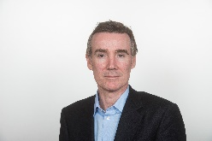

In addition to holding the chairmanship of Kantar, Adam Crozier currently holds the Chairmanships of Whitbread plc and ASOS plc. He also held the Chairmanship of Stage International until 2019. Previous non-executive directorships include G4S plc, Debenhams plc and Camelot Group plc.

Adam has had over 20 years’ experience as a CEO across four different industries, most recently as the CEO of ITV plc from April 2010 to June 2017. Over that time he has built a strong track record in transforming companies and leading successful management teams. Under Adam’s leadership ITV was transformed into one of the most successful and dynamic media and content companies in the world and its financial performance improved dramatically, with earnings per share increasing by over 800%.

Before joining ITV, Adam was chief executive of Royal Mail for over seven years. Prior to Royal Mail he was CEO of The Football Association between 2000 and 2002 and Joint CEO of Saatchi & Saatchi from 1995-2000.

Reed Cundiff, CEO North America Region

Reed Cundiff joined Kantar from Microsoft where he held the position of General Manager, Customer and Market Research. During that period he was responsible for the digital transformation of Microsoft’s customer and consumer insights and revamped his team into an internal consulting team.

Prior to Microsoft, Reed had a series of roles in the technology sector, as a manager and consultant at Gartner and Yankee Group and as one of the founding executives of Compete.

Caroline Frankum, CEO, Profiles division, Kantar

Caroline Frankum is a multi-award-winning CEO with a high-level of expertise in media, dgital, first party data, brand & comms strategy, tech-driven automation, and change leadership. As Global CEO of the Kantar Profiles division, she is responsible for running our multi-million-dollar first party data division that powers insight delivery and analytics for world-leading consumer, media, tech, publisher, consultancy, healthcare, market research and e-commerce brands via compliant, programmatic access to over 88m respondents across the globe, including our exclusive LifePoints panel.

Caroline joined Kantar in 2016 and prior to this she worked client-side in media for 15 years in influential roles at leading media companies, including Classic FM, The Mirror Group, Five, Disney, ITV, UKTV and Sky. This was followed by seven years at Omnicom where she was EMEA CEO for brand & comms specialist Agency Hall & Partners.

One of Caroline’s biggest passions is helping businesses transform and grow in profitable and purposeful ways by creating more inclusive and diverse environments, where the only barriers to success are personal choice and professional competence. This has led to her being voted:
- A 2020 Business Woman of The Year by CEO Today
- A Top 100 HERoes Champion of Women in Business in 2019 and 2018
- The 2019 winner of the Forward Ladies ‘Corporate Leader’ Award for London & The South
- A ‘Highly Commended’ Corporate Leader at the Forward Ladies 2019 Business Woman of The Year Awards
- A Top 10 Market Research Diversity Champion by WIRE (Women In Research) in 2017

Caroline has a BA Hons in Business Management and a Diploma in Market Research.

Ian Griffiths, Chief Financial Officer & Deputy CEO

Ian Griffiths joined Kantar as CFO in January 2020. Prior to joining Kantar Ian was COO and CFO of ITV plc, the biggest commercial broadcaster in the UK and home to ITV Studios one of the world's largest international content companies. At ITV, Ian played a key role in creating the environment to transform ITV from being reliant on UK advertising to a more diverse international and increasingly digital business.

Before joining ITV Ian was group finance director of Emap plc, the international magazine, radio and B2B business. Ian has significant experience in organisational change, M&A, managing costs and driving working capital and, as a result of this, delivering strong returns for shareholders all of which will be important to Kantar as we embark on the next stage of our growth journey.

Dr Michelle Harrison, CEO Public Division, Kantar

Dr Michelle Harrison is the CEO of the Public division of Kantar, working with governments, multi-lateral governmental bodies and international development organisations in all aspects of public policy, political advisory and public affairs. She is recognised as an innovator in the use of evidence to inform decision making, and in approaches to programme evaluation.

Michelle is an expert in applied behavioural approaches and public communications. She is the founder of the WPP Executive Education Programmes in Public Communications and Behaviour Change at the University of Oxford and the National University of Singapore.

More recently, with Women Political Leaders, she launched The Reykjavik Index for Leadership, the first international measure of how women are perceived in terms of leadership, listed as ‘best of Davos 2019’.

Richard Ingleton, CEO, Insights division, Kantar

Richard Ingleton joined Kantar as Global CEO for TNS in July 2013. Prior to this he led the global customer practice at E&Y for five years and, prior to that, the global marketing effectiveness practice at Accenture. He has also held roles at Virgin and Tata.

Richard started his career in 1988 with Andersen Consulting working on a range of strategy and technology projects. He then worked at Virgin as a Corporate Development Director before establishing the European business of Inforte, a sales and marketing consultancy, which led him back into consultancy at Accenture and EY. It was whilst at EY that he was seconded to Tata Steel Europe as the Group Marketing Director

Richard has a Bachelor’s degree in Economics & Philosophy from The University of Birmingham. Outside of work Richard enjoys, golf, travel, literature, writing and philosophy.

Wayne Levings, President and Global Chief Client Officer
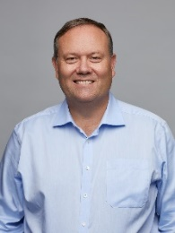

Wayne Levings oversees clients and offer via the network of Kantar enterprise client directors. Wayne was previously responsible for a number of the Kantar operating companies, including IMRB, Kantar Retail (where he had been CEO) and The Futures Company. Wayne chairs the Kantar Innovation Board and sits on the main Kantar Board.

Serge Lupas, Interim CEO, Media division, Kantar

Serge Lupas leads the Media division of Kantar on secondment from AlixPartners where he is Managing Director of their UK TMT Practice. Serge has previously held leadership positions with Tiscali A/S and McKinsey & Company. He has a master’s degree in economics and finance from the Institut d’Etudes Politiques de Paris and a master’s degree in industrial engineering form the École Centrale de Paris.

John McHarry, Chief Information Officer

John McHarry has been CIO of Kantar since January 2014, and was previously the CIO of TNS. John joined Research International as CIO from AB InBev in January 2008 where he held a number of country, regional and global technology leadership roles, based both in the UK and Belgium.

Josep Montserrat, CEO Worldpanel division, Kantar
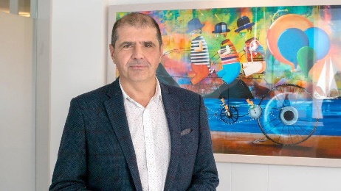

Since becoming global CEO of Kantar’s Worldpanel divisions in 2007, Josep Montserrat has led a high-performing team which has successfully transformed the business worldwide. Now encompassing 4,000 employees across 40 countries, the Worldpanel division is recognised as a global expert in consumer and shopper behaviour. Offering a deep understanding of client needs, Josep and his team have developed a new generation of panel services, using cutting edge technology and their extensive market experience to align the areas of purchasing, consumption and media exposure.

Under Josep’s leadership, Worldpanel has become a unique place within which to develop talent, with over 75% of the workforce based in an office that has been recognised externally as a Great Place to Work. As President of Kantar Spain, Josep is leading the group’s go-to-market position, to present a unified and more complete offer that leverages the full range of client solutions offered across the business.

Before becoming Global CEO of Worldpanel he held a range of senior leadership roles in the Group across Spain, Southern Europe and Latin America. He began his career working in the FMCG sector. A recognised consumer expert, Josep is involved with a number of FMCG trade bodies and is regularly interviewed in the media, with the goal of helping brands and retailers bring the voice of the consumer into the core of their relationships.

Alexis Nasard, CEO, Kantar

Alexis Nasard is Chief Executive Officer of Kantar. Alexis joined Kantar on 30 December 2020, with almost 30 years’ experience in the FMCG and retail world. Before joining Kantar, Mr Nasard is was CEO of Bata. Prior to that, Alexis spent six years at Heineken, culminating in the position of President of Western Europe Business and Global Chief Marketing Officer. Earlier, he worked for 17 years with Procter & Gamble, in a variety of marketing and general management roles.

Mr Nasard holds an MBA degree from UC Berkeley’s Haas School of Business, USA, and an MS/BS degree in Civil Engineering from Saint Joseph University, Lebanon.

Philip Smiley, CEO, Consulting division, Kantar
Phil Smiley is CEO of the Consulting division of Kantar. He joined Kantar group in 1999 after an 8-year career in the retail industry in the UK. Phil worked as a consultant and partner across multiple clients, industry sectors and markets including living and working for extended periods in the US, China and South East Asia markets.

In a world where growth has shifted to uncomfortable places the consulting division uses its data, technology and advisory capabilities to help clients uncover new sources of growth, create strategies and plans to tap growth and mobilise the organisation to capture and convert growth in the market. Phil plays an active role with clients, advising on sales and marketing issues and opportunities, he contributes to our global thought leadership and analysis on consumer, shopper and retail/commerce trends.

